Agenda: CTG Observer Members Meeting

Thursday 1 March 2018, 14:00-17:00

Wellcome Trust, Gibbs Building, 215 Euston Road, London, NW1 2BE
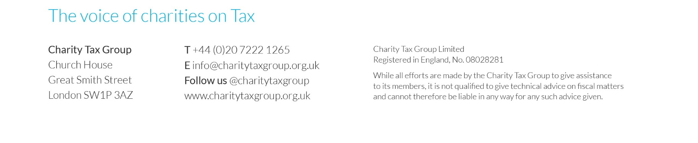
13.45 | - Welcome and coffee
14.00  MTD for VAT | - Presentation by Heather Elliott, HMRC, on Making Tax Digital for VAT  - Q&A
15.00  VAT updates | - HMRC VAT guidance on grants  - Advertising  - Telephone VAT Inspections  - Review of case law developments  - VAT grouping  - OTS Review follow-up  - Commission proposals on VAT reform
15.35 | - Coffee break followed by CTG updates
15.45  Giving updates | - Updates from the Gift Aid practical issues working group  - Update from HMRC working groups including donor benefits  - Gift Aid research  - Implications of Scottish devolution for Gift Aid  - Giving incentives
16.30  Other tax issues | - Charity Tax Commission  - Engagement with HMRC: feedback requested on penalties, unexpected tax returns etc  - Business rates  - Tax Strategy  - Museum and Galleries Exhibition Tax Relief  - Trusts Registration Service  - Apprenticeship Levy

