Agenda: CTG Observer Members Meeting

Thursday 28 June 2018, 14:00-17:00

Mary Sumner House (24 Tufton Street, Westminster, London, SW1P 3RB)
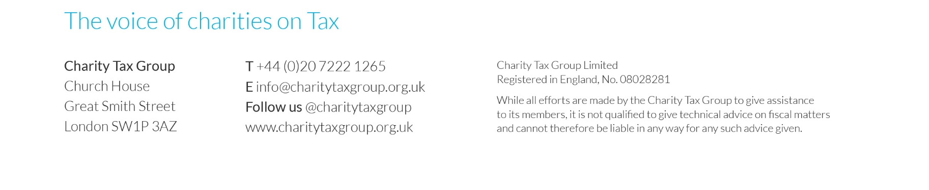
13.45 | - Welcome and coffee
14.00  VAT updates | - Advertising  - Making Tax Digital  - Review of case law developments including University of Cambridge, Wakefield College and Paragon  - European developments  - VAT consultations  - AOB
15.15 | - Coffee break followed by CTG updates
15.25  Other tax issues | - Charity Tax Commission  - Engagement with HMRC: feedback requested on penalties, unexpected tax returns etc  - Business rates  - Common Reporting Standard  - Apprenticeship Levy  - IR35 – Off-payroll working  - Corporate Criminal Offence  - RDEC claims  - Miscellaneous trading limit
16.10  Giving updates | - HMRC Gift Aid research  - Updates from the Gift Aid practical issues working group  - Update from HMRC working groups including donor benefits and retail Gift Aid  - GASDS  - Giving incentives including IHT and Living Legacies  - Charity tax statistics (expected to be published on 28 June)

