Agenda: CTG Observer Members Meeting

9 July 2019, 14:00-17:00 – Wellcome Trust (215 Euston Road, London, NW1 2BE)

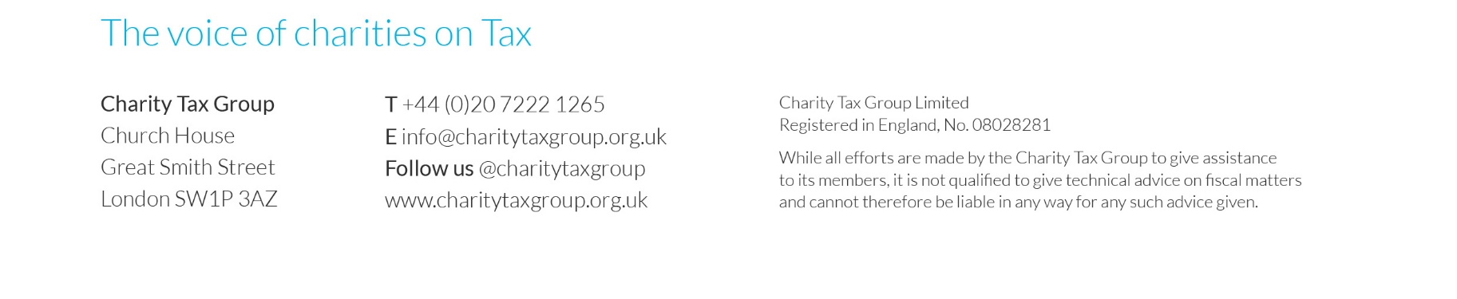
Overview | - Autumn Budget priorities  - Charity Tax Commission
VAT updates | - Making Tax Digital (possibly including an update from HMRC)  - Advertising  - VAT guidance on issues including sponsorship  - Partial exemption consultation  - Flexibility of RCP commercial activity rules for new buildings?  - CTG research project to quantify the value of VAT reliefs for charities  - Review of case law developments including  - Domestic reverse charge for building and construction services
Giving updates | - Updates from the Gift Aid practical issues working group, including  - Future of Gift Aid subgroup  - Data issues and common errors  - Feedback from recent Gift Aid audits  - Facebook Donate  - Gift Aid education in fundraising packs  - Intermediaries fees  - Gift Aid donor benefits  - Aggregated donations  - Charitable Remainder Gifts  - Gift Aid Awareness Day 2019  - Declaring Gift Aid income
Other issues | - Charity tax returns  - Business rates  - IR35 (Off-payroll working)  - 5MLD and Trust Registration Service (TRS)  - Apprenticeship Levy  - Tax liability for overseas payments  - Employer provided living accommodation  - Social Investment Tax Relief

