Mrs Jenny Carter
Director of UK Accounting Standards
Financial Reporting Council
8th Floor
125 London Wall
London, EC2Y 5AS

Sent by e-mail to ukfrs@frc.org.uk on 20 October 2017

Dear Mrs Carter

FRED 68 Draft amendments to FRS102 The Financial Reporting Standard applicable in the UK and Republic of Ireland – Payments by subsidiaries to their charitable parents that qualify for Gift Aid

The Charity Tax Group (CTG) has over 500 members of all sizes representing all types of charitable activity. It was set up in 1982 to make representations to Government on charity taxation and it has since become the leading voice for the sector on this issue.
Charity Tax Group applauds the prominence given by The Financial Reporting Council (FRC) to addressing an important issue for our members and others in the public benefit entity arena. We have dealt with many queries from members about the accounting issues this has led to. What has caused particular unease and confusion has been the lack of consistency and the variety of accounting treatments required of our members by different firms of auditors in this area.

As a result, we welcome the proposals in the FRED. However, we do not consider that it is appropriate for us to comment in detail on the proposals as these are accounting issues rather than tax ones. That would go beyond our remit.

This means that our main point is that we believe that the proposals, if adopted, will, by and large, bring consistency and clarity to accounting when a charity’s trading subsidiary makes a gift aid payment to its parent. We consider that this to be a very positive development.

Yours sincerely
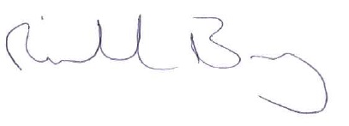

Richard Bray
Vice-Chairman

