HMRC Gift Aid and Intermediaries Consultation

Response from the Charity Tax Group

5 October 2016

Introduction

- The Charity Tax Group (CTG) has over 500 members of all sizes representing all types of charitable activity. It was established in 1982 to make representations to Government on charity taxation and it has since become the leading voice for the sector on this issue.

- CTG has participated in the various Gift Aid and intermediaries working group meetings and this response follows those discussions and consultation with our members, including our Gift Aid working group, which comprises over thirty charities with significant Gift Aid claims per year. CTG welcomes the opportunity to respond to this consultation and would be happy to meet officials to discuss this further.

‘Do the Regulations achieve the desired outcome without causing any unintended issues?’

Overview

- CTG welcomes the Government’s commitment to simplifying the administration of Gift Aid claimed through intermediaries and we are hopeful that it will remove barriers to donors trying to make a Gift Aid claim. It is welcome that the changes are optional, and this should be made clear in all communications when the new rules are enforced.

- However, it is important that the practical implications for the charity are proportionate so that any increase in Gift Aid income is not negated by an additional administrative and cost burden. It is also important the user journey is simple and not confusing for donors. For this reason, we believe that the Annual Statement should be made optional or apply only to donors making more frequent or larger donations, and that there should be a passive rather than positive confirmation process for charities confirming Gift Aid eligibility each year.

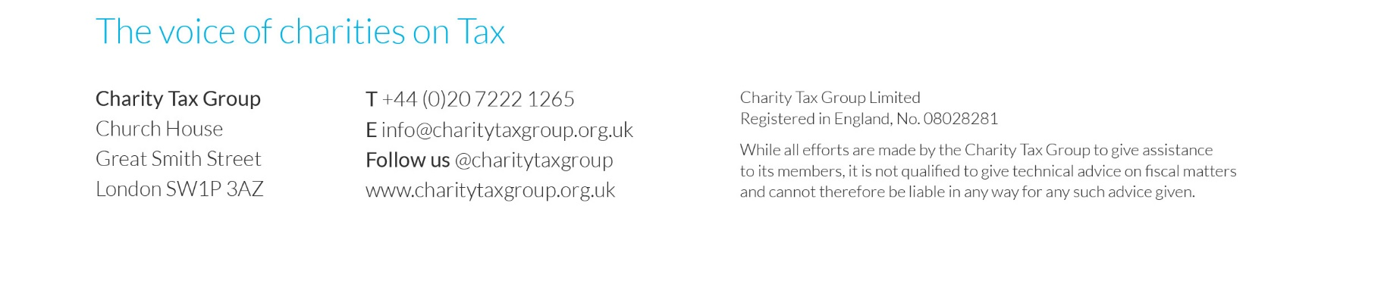
- While we are confident that the new rules will work well overall for online platforms, we believe that further targeted work is needed to improve the process for claiming Gift Aid on SMS-giving. We consider that this is where the greater benefits of changes in this area can lie. We also believe that the Government should give serious consideration to broadening the applicability of the rules to allow a single Gift Aid declaration to be applicable to all intermediaries and consider the long-term viability of introducing changes that are consistent with the aspirations of having a Universal Gift Aid Declaration Database.

Annual Statement and Donor Authorisation

- CTG understands from discussions with intermediaries that the technology is largely in place to generate an annual statement of donations made during a tax year for donors. Improving understanding among donors of the link between tax paid and Gift Aid is very welcome and should also help higher rate donors to claim relief, although we still have reservations about whether the introduction of a mandatory Annual Statement is the most effective way of achieving these goals.

- As discussed in the working group meetings, feedback from fundraisers indicates that requiring “positive authorisation” from donors will likely result in reduced Gift Aid take-up year-on-year. This is not usually because the donors are no longer eligible for Gift Aid, but, instead, because of donor apathy they may miss the notification from the intermediary, or resent having to fill in another form when their position is unchanged (undermining the simplification of signing a single declaration for that intermediary). For these reasons we still believe that it would be preferable for there to be a “passive authorisation” process whereby the donor is treated as eligible for Gift Aid unless they notify the charity otherwise (functionality that would be available on online intermediary platforms). If positive authorisation is required, it would be preferable for this to occur at the time of a donor’s first donation in a year rather than through a separate authorisation process with an arbitrary cut-off date.

- There are no requirements for Annual Statements (apart from for Retail Gift Aid) and “positive authorisation” for donations received through traditional fundraising means. Any attempt to broaden out the use of Annual Statements and “positive authorisation” to all donations would be counter-productive due to the additional administrative burden with the likelihood of donor apathy leading to a substantial value of eligible donations no longer being Gift Aided.

- It is welcome that the Annual Statement will be required to include an explanation that donations made directly to charities and donations through other intermediaries are not included in the statement. However, there is a real risk that this will be missed and could confuse donors and may lead to less effective compliance, particularly where donors may have made other offline donations too.

- We would suggest that the threshold of £5 is too low given that it will apply to donors that have made multiple donations. Donations made through online platforms will often be £10 or more and we would suggest that the threshold would more appropriately be £20, particularly if the Annual Statement is to remain mandatory.

Costs to intermediaries and charities

- Charities benefit from a good range of intermediaries with whom they can work to receive donations and claim Gift Aid. Within this marketplace there are a variety of cost options and fees are generally affordable and cost-effective. There will inevitably be an upfront cost to intermediaries in setting up this new functionality and maintaining increased contact with donors and charities. While we do not suggest that Government should regulate intermediary fees, and competition within the marketplace should ensure fees do not escalate, it is an important consideration if intermediaries do decide to increase their fees in the short term.

- Charities will also face their own initial investment costs in ensuring that their databases are compliant. While we are hopeful that any set-up and ongoing costs will be lower than increased Gift Aid income, it is important that Government, intermediaries and charities continue to work together to ensure that costs are kept as low as possible. In particular, it would significantly reduce the cost to intermediaries of having to send out annual statements if these could be done via email rather than in letter form.

SMS giving

- Overall, the proposals do appear to be mainly focused on online platform intermediaries (where Gift Aid take up rates are already high) at the expense of SMS giving (where Gift Aid take up rates are currently low). We have received feedback from mobile operators that the proposals will not be that practical for mobile giving. For example, how do annual statements work with a text message? This is frustrating as one of the stated aims of this policy was to increase uptake of Gift Aid on these types of donations, which are growing with the increased use of smartphones and impulse donations. We suggest that Government commits to further work with charities and the mobile sector to maximise the eligible Gift Aid uptake so what is started here can result in ongoing benefits.

Future reform

- CTG believes that there is now the opportunity to consider broadening the scope of the rules to allow intermediaries to pool data and share a single declaration across platforms. In general, donors do not give through individual platforms out of choice, they do so because that is where the beneficiary of their donation has chosen to host their fundraising appeal. It would not be uncommon for one donor to make five donations in a year through five different intermediaries and at present the new rules would not simplify the process for this donor. We believe that further exploration of this proposal would help to improve the user journey and result in substantive simplification for donors.

- Advances in technology and HMRC’s making tax digital programme are likely to present fresh opportunities to increase Gift Aid take up on eligible donations. This may pave the way to meeting the aspirations of the Universal Gift Aid Declaration Database (UGADD). If implemented correctly, this could result in a much simpler process for charities, intermediaries and donors and enable HMRC to ensure that Gift Aid is only paid by donors that have paid sufficient tax to cover their claim. Both the sector and Government have shown an interest in such a concept. It will need a significant amount of work to resolve Gift Aid practicality, concerns about data protection and day-to-day operation. But we encourage HMRC to commit to looking at the long-term viability of such a proposal.

Charity Tax Group
October 2016

