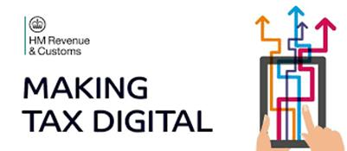
MTD Update for Agents #11: Date 28 October 2019
Welcome to edition #11 of our Making Tax Digital (MTD) update for agents.
If there’s any subject you’d like us to cover in future updates or you want to be added to the distribution list for this publication, please let us know via the MTD mailbox at:
makingtaxdigital.mailbox@hmrc.gov.uk

In this edition:
- Service Availability
- Overseas based clients
- Sign up timelines for VAT Deferred businesses
- Manage your clients
- Update to MTD VAT Notice 700/22
- Changes to the Agent Services Account
- TAXAdviser article
- YouTube videos
- Webinars
- Useful links

Service Availability
There is currently no planned downtime for either the Agent Services Account or the Making Tax Digital system.

Agent services account: service availability and issues https://www.gov.uk/government/publications/agent-services-account-service-availability-and-issues

Making Tax Digital for VAT: service availability and issues https://www.gov.uk/government/publications/making-tax-digital-for-vat-service-availability-and-issues
We have recently updated this page to inform customers of an issue affecting some overseas-based clients. Read on for further information.

Key Updates
Overseas based clients

Some agents, when trying to sign up their overseas clients to MTD, have found them being incorrectly treated as UK based companies. This means they are unable to complete the sign up process.

If your client is affected, and their VAT return is due, please submit it as normal through HMRC Online Services.

Not all overseas customers are affected by this issue, but we do apologise for any inconvenience this has caused.

We will notify you in a future issue of Agent Update when this issue is resolved.

Sign up timelines for VAT Deferred businesses

Attached to this edition’s email is a MS PowerPoint file and a (non-interactive) PDF giving guidance on sign up dates for deferred customers.

We created something similar for non-deferred customers and received lots of positive feedback on it so we hope you find this revised version useful.

All previously deferred businesses should submit their last non-MTD return and ensure any payment/repayment has been finalised before signing up to MTD.

There are different sign up dates depending on whether payment is by Direct Debit or not.

Sign up dates are especially important for monthly customers as the sign up window is much shorter than for other customers.

Sign up for Direct Debit paying monthly customers is only available between 15 and 27 November.
Manage your clients

Since mid-August it’s been possible to manage your client’s details using this GOV.UK page:
https://www.gov.uk/guidance/update-your-clients-business-details-if-theyre-part-of-the-making-tax-digital-for-vat-pilot
If your client is signed up for Making Tax Digital for VAT, you can use this page to:
- change your client’s business name if they’re a limited company
- update your client’s principal place of business
- view their VAT certificate
- change their VAT Return dates
- cancel their VAT registration
- view details of returns submitted by software under Making Tax Digital (NEW)
- opt out clients from MTD (NEW)
View previous returns
Agents are now able to see details of returns submitted under Making Tax Digital from the ‘Manage your clients details’ service. Businesses can access this information using their Business Tax Account.
Opt Out of MTD
You should only opt out clients where they have signed up voluntarily and their annual taxable turnover is under the current threshold of £85K.

Using the green ‘Start now’ button on the GOV.UK page, enter your Agent Services Account (ASA) credentials. You’ll be prompted to enter your client’s VAT number - if it’s entered correctly select the ‘Change VAT details’ button and use the ‘Continue’ button to proceed to the ‘Your Client’s VAT details’ screen and select the ‘Opt out’ link at the bottom.

You need to confirm whether the taxable turnover of the business has been above £85K since 1 April 2019. If you select ‘Yes’ the screen below will display:

If you select ‘No’ you are presented with this screen:

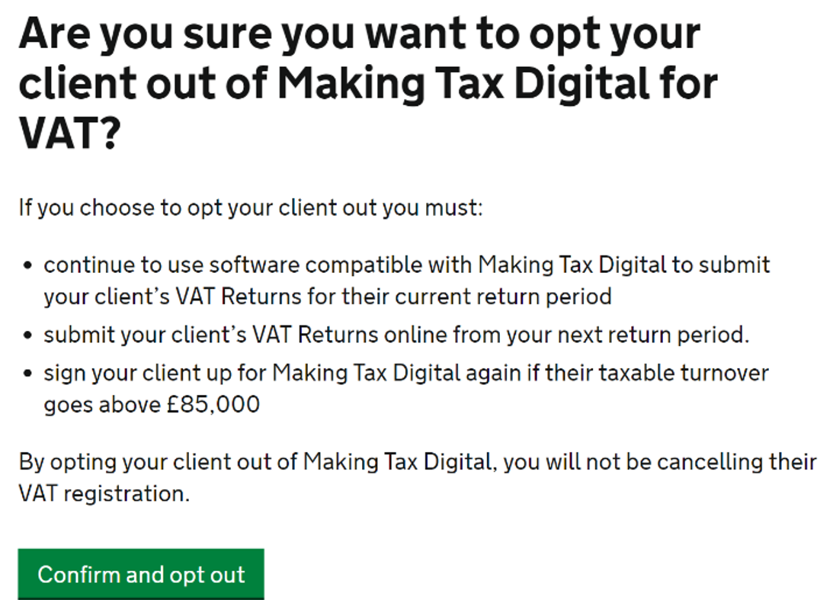

Selecting ‘Confirm and opt out’ is followed by:

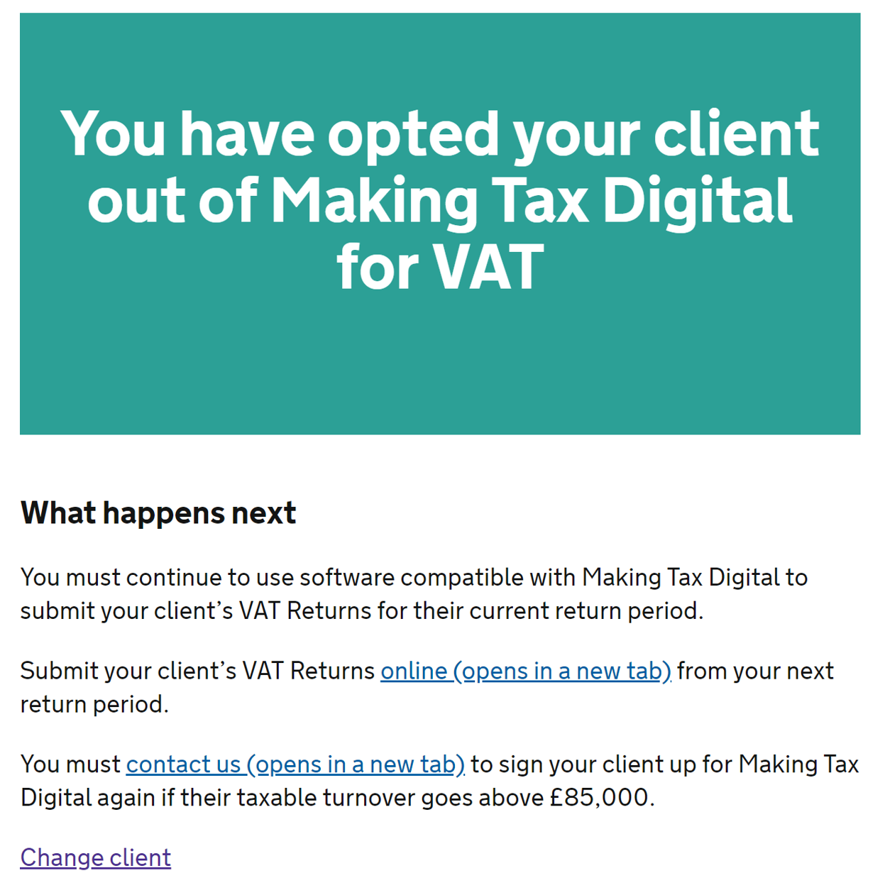

Businesses opt out of MTD using their Business Tax Account. There is an ‘Opt out’ link on the ‘Your Business Taxes’ screen. The process to follow is then very similar to the one for agents described above.

Update to MTD VAT Notice 700/22

We have updated the VAT notice (https://www.gov.uk/government/publications/vat-notice-70022-making-tax-digital-for-vat) with information on how businesses with complex or legacy IT systems can apply for additional time on the digital link element of MTD for VAT. The new guidance is at ‘4.2 .1.3 Digital links deadline extensions’.

Changes to the Agent Services Account

There have been a couple of changes to the Agent Services Account. From 7 October:

- Partnerships and Sole Proprietors will be asked for their National Insurance Number and date of birth (in addition to the existing information required) when creating a new Agent Services Account.

- Overseas companies creating an Agent Services Account will be asked for their Anti-Money Laundering Supervision (AMLS) details but will be able to carry on through the journey without them if the country where they are based doesn’t provide them. There is a check box at the end of the journey where agents can indicate companies comply with the AMLS regulations within the country where they are based.

TAXAdviser article

At the beginning of October TAXAdviser interviewed Teresa Middleton, Director of HMRC’s Making Tax Digital programme. The article can be found here: https://www.taxadvisermagazine.com/article/time-transition

An update on the figures given in the article – there are now over 1.2 million customers signed up to the MTD service and they have made over 1.7 million software submissions.

YouTube videos

We’ve revised 2 videos on our MTD YouTube channel at https://www.youtube.com/playlist?list=PL8EcnheDt1zi1ipk1qexrwdAU5O6LS84a

They are:

How to sign up to Making Tax Digital for VAT
https://www.youtube.com/watch?v=OyWJz0fSDE4&list=PL8EcnheDt1zi1ipk1qexrwdAU5O6LS84a&index=11

Making Tax Digital for VAT: What is compatible software?
https://www.youtube.com/watch?v=EVC_UuErOB0&list=PL8EcnheDt1zi1ipk1qexrwdAU5O6LS84a&index=12Updated

Webinars
Our webinars continue to receive positive feedback. Consequently, we’ve scheduled two further Talking Points webinars on creating Agent Services accounts and signing up clients to MTD.

The webinars are on Thursday 14 November at 12 noon and Thursday 28 November at 2pm. Both webinars last an hour.

You can register for these webinars via this GOV.UK page: https://www.gov.uk/guidance/help-and-support-for-agents

Useful links
Making Tax Digital for VAT (GOV.UK Collection)

Making Tax Digital for VAT as an agent: step by step

Check when a business must follow the rules for Making Tax Digital for VAT

Find software that's compatible with Making Tax Digital for VAT

Create an agent services account

Sign in to your agent services account

Copy across existing clients to your agent services account

Sign up for Making Tax Digital for VAT

Keep digital records for Making Tax Digital for VAT

Manage your client's details for Making Tax Digital for VAT

Help and support for Making Tax Digital

VAT Notice 700/22: Making Tax Digital for VAT

